Vendor-specific programming interfaces

The main bottleneck of the 1149.1 standard was requirement of 4, 5 or 6 pins. Obviously, it was a bottleneck for low pin count circuits. For example, if JTAG functionality was limited to a simple Flash programmer interface for a low-cost devices family, implementing whole robust Test Access Port interface was not feasible due to its complexity.

There were two main approaches to overcome this problem:

- Enforcing a new official JTAG expansion for reduced pin count - companies such as Texas Instruments overcame this problem by introducing a reduced pin count JTAG standard known as IEEE 1149.7 [Chi]. Nowadays, Texas Instruments' cJTAG IP core whose name is an abbreviation of “Compact JTAG” is claimed to be the very first semiconductor solution having the standard fully implemented. Finally, 1149.7 was ratified in late 2009. Naturally, 1149.7 standard did not replace 1149.1 in full. Potential risks of such replacement are well described in [IPE].

- Implementing a custom, reduced pin count interface designed from scratch - unlike Texas Instruments, various vendors such as ARM or ST Microelectronics introduced their own JTAG-like protocols with reduced pin count. ARM introduced SWD, whereas Atmel introduced PDI and DebugWIRE for 8-bit processors with limited resources [Mik]. As a result, even Texas Instruments developed its own Spy-Bi-Wire protocol used to program MSP430 devices [MSP]. In most cases, such devices provides support of both 1149.1 JTAG and vendor-specific interfaces with a well-defined procedure of switching between the interfaces.

General structure of a reduced pin count interface

Typically, vendor-specific protocol is a two-wire protocol. The first pin is used as a clock signal and the second pin is a bi-directional data bus with the following generic configuration:

- Pin acts as a transmitter when data are sent to the processor;
- Pin acts as a receiver when acknowledge signals, ID codes or read memory values are sent by the processor.

Example of an interface of Atmel XMEGA AVR devices family that makes use both of a default JTAG and a two-wire vendor-specific interface is shown on Fig.XX.

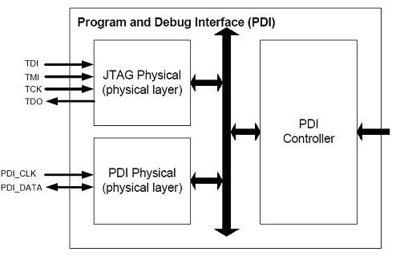

Fig. XX Example interface supporting both JTAG and vendor-specific interface (PDI). Source: [Equ]

Two common vendor-specific interfaces, SWD and PDI, are described below. Description of the SWD interface is based on its implementation in STM32F4 devices family [STM], whereas description of the PDI interface is based on its implementation in AVR1612 [APD].

Description of SWD programming interface

The name SWD is an abbreviation of “Serial Wire Debug”. This serial interface provides an alternative to a typical 1149.1 JTAG interface in ARM processors family. It was introduced with the Cortex-M family [Cor] and finally specified in [AD5]. Some Cortex-M based MCUs support only SWD interface. Nowadays, cores of ARM processors integrate both Serial Wire and JTAG debug ports. Both interfaces make use of the same I/O pins.

SWD makes use of only two pins used in the JTAG interface: TMS becomes its Serial Wire Data IO (SWDIO) pin and TCK becomes its serial wire clock (SWCK) pin. However, sometimes an additional trace output TRACESWO pin is used to access the Serial Wire Viewer that can be accessed only by SWD. By default, JTAG port is active. To switch from JTAG to SW-DP, a special sequence of bits described in [STM] must be sent on the TMS pin while TCK pin is set active.

SWD interface allows read and write operations on both DPACC and APACC banks of registers. All bits are transmitted LSB-first. Each transaction consists of three phases:

- An 8-bit long packet request is transmitted by the host via SWDIO pin. Packet requests defines operation type (read/write) and registers that are accessed (DPACC or APACC). It also includes an address field of the register and a parity bit.
- Target replies the host with an acknowledge response. SWD uses the same acknowledge values as JTAG-DP (OK and WAIT), but it also introduces a new FAULT acknowledge.
- Target or host transmits 32 bits of write/read data, expanded with an additional single parity bit.

[TODO] Zastąpić te 3 punkty grafiką, za mało obrazków w tym rozdziale!!!

Cortex-M3 family expanded the interface with an auxiliary CoreSight debugger block. This block enables variety of debugging possibilities, such as a Serial Wire Viewer macrocell enabling a real-time data tracing by SWD pins. As a result, the following data become traceable [Epr]:

- Program counter;
- Read/write data cycles;
- I/O port states;
- Variable values;
- Input and output ports of interrupt handling routines;
- Event counters;
- Data about single instruction execution time.

All of the data above may be visualized in Keil Microvision Logic Analyzer[SWV].

Description of PDI programming interface

The name PDI is an abbreviation of “Program and Debug Interface”. It supports high-speed programming of all species of non-volatile memory and on-chip debugging. As SWD interface, it makes use of two pins. However, an additional VCC/GND connection between the programmer and the device is also required. Mandatory data pins are:

- PDI_CLK: clock input acting as a reset pin;
- PDI_DATA: data input and output pin acting as a test pin.

PDI physical interface is serial and it uses a standard UART frame format as shown on Fig.XX.

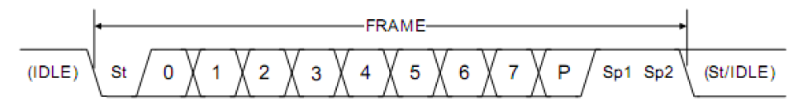

Fig.XX UART frame format used in PDI interface. Source: [APD]

PDI may be either in transmit or receive mode. By default, it is in receive mode in order to wait for a start bit. As in a standard 1149.1 JTAG interface, input data are sampled on a rising edge of PDI_CLK.

PDI must be enabled before it is used. As in SWD interface, a special sequence must be sent on PDI_DATA and PDI_CLK pins. In the case of PDI, switching procedure is much simpler. It consists of setting PDI_DATA high for a period longer than the equivalent external reset minimum pulse width. An additional process is required to get access to non-volatile memories and their controller for programming. User must send a correct 64-bit wide NVM key in the PDI while choosing the KEY instruction. PDI interface is automatically disabled if there is no activity on the PDI_CLK line for approximately 100 μs.

Control of PDI is made by a small set of its own 8-bit long commands. Most of these commands define an operation (load or store data) and applied mode of addressing (indirect or direct). Additional information about address size or pointer access are required when respectively direct or indirect addressing is used. Programming instructions enable a wide range of operations such as chip erase, reading the non-volatile memory, loading/erasing page buffer or loading/erasing application section. CRC value of Flash memory and application section are accessible too. Moreover, even boot loader and calibration sections may be accessed.

References

[Chi] http://chipdesignmag.com/display.php?articleId=2668
[IPE]http://blogs.ip-extreme.com/2010/03/myth-busted-ieee-11497-does-not-replace-ieee-11491.html
[MIK] http://www.mikrocontroller.net/articles/DebugWIRE
[MSP] Texas Instruments, MSP430™ Programming Via the JTAG Interface:User's Guide, SLAU320M.
[Equ] http://www.equinox-tech.com/products/details.asp?ID=1429
[Cor] http://www.support.code-red-tech.com/CodeRedWiki/HardwareDebugConnections
[AD5] ARM Debug Interface v5
[STM] STM32xx manual
[Epr] Paweł Adamczyk, Serial Wire Viewer:„Śledzenie” ARM-ów w realu, Elektronika Praktyczna 2/2009, s.124-127.
[SWV] Robert Boys, Serial Wire Viewer (SWV) for ARM Cortex-M3 Processors ARM Real-Time Trace aids debugging, Version 2.1, ARM, Ltd.
[APD] AVR1612: PDI programming driver

